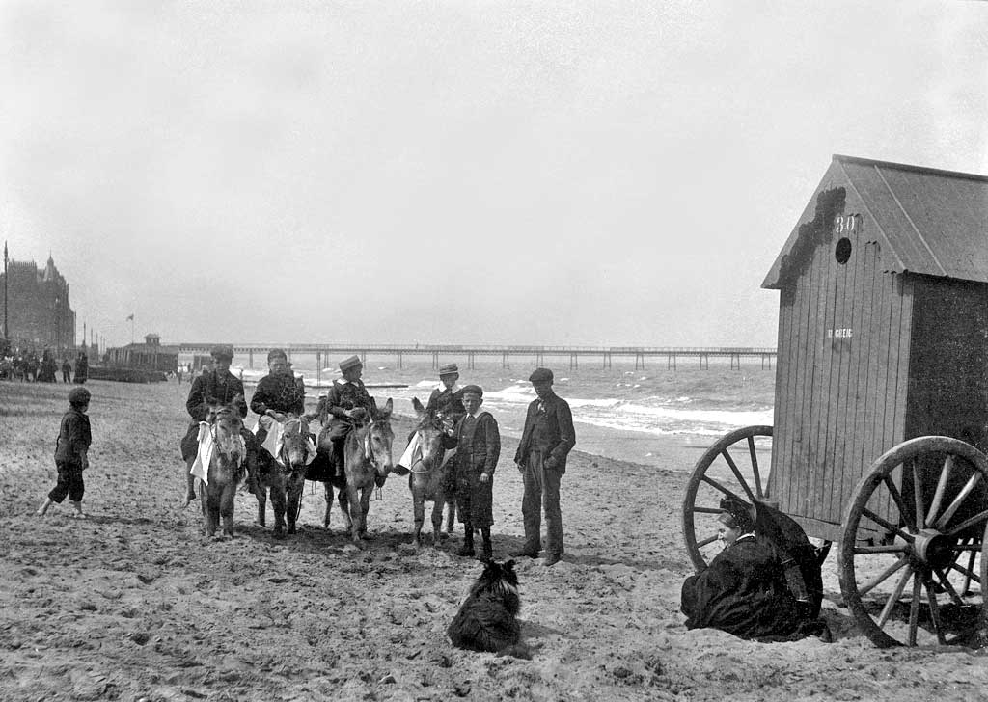
History and Geography
Significant people – Captain Cook
Timelines – visiting the beach through the ages
Nation and nationality – The commonwealth and the commonwealth games
Location – identify key features (towns, cities, rural, farm, mountains etc.)
Fieldwork - Identifying physical and human features Natural & manmade)
Contrast countries – comparing the UK with Australia (seasons, weather & animals
What would you find in a place like this?
Computing, Art, DT and Music
Multi-media – Class blog, internet safety and communication
Printing – bunting and aboriginal art
Circuits – design and make a lighthouse
Power sources – Design and make a boat
Listen and perform music – use rhythm and beat

PE
Swimming – use basic strokes
Athletics and games - Use rolling, hitting, running, jumping, catching and kicking skills in combination.
• Develop tactics
Science
Basic needs – exercise, growth and health
Electricity - circuits
Maths
Number – Multiplication and division
Number – Fractions
Geometry – Position and direction
Number – Place value (numbers to 100)
Measurement – money and time

English
Labels and captions – locations/places
Poems – Seaside poems
Narrative/story writing – Why Kangaroos hop
Information – Fact file on different locations
Recount/ Retell – Trip to the beach
RE and PHSE
Judaism – Who is Jewish and how do they live?
Respect and Democracy – different cultures, communities and institutions

Figure 1What would you find in a place like this?

