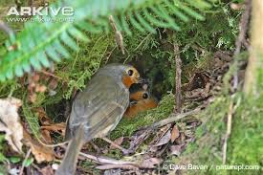

**History and Geography**

**Migration**

**Where our food comes from**

**Seasonal changes**

**PSHE and RE**

How do I stay safe How do I stay safe

How have I changed?

Who do Christians say made the world? [Creation]

How should we care for others and the world, and why does it matter?

Why does Easter matter to Christians? [Salvation]

Science

Animals including humans

Seasons

Plants

**Computing, DT, Art and Music**

**Programming- Scratch**

**Animating – Jack and the Beanstalk**

**Time lapse - filming plants growing**

**Art and DT- Bird box, lifecycles, Easter cards, animal homes**

**English**

**Traditional Tales- The Ugly duckling & Jack and the beanstalk**

**Recounts- Visit to Slimbridge**

**Explanations – Lifecycles**

**Poems – Spring**

**Instructions- Planting seeds**

Maths

Place value within 20

Addition and subtraction within 20

Numbers up to 40 or 50

See How We Grow