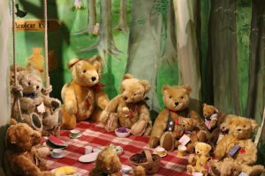

**PSHE and RE**

Rules and responsibility

Respect for others and ourselves

Christians, Muslims and Jews – What they believe, scared places and times, faith communities, caring for the world and why it matters

**Computing, DT, Art and Music**

Paint programs, programming

Nests using different materials, bird boxes

Bread and Porridge

Painting, rubbing and printing

Andy Goldsworthy

Vivaldi- The four seasons

Performance and composing

**History and Geography**

Toys

Weather

School environment

Conservation

**Science**

Seasons

Weather

Plants and Trees

**Maths**

Place value

Addition and Subtraction

Counting in twos

Number facts

**English**

Information text – Trees, Toys

Narrative text – We’re going on a bear hunt, The three bears, Rama and Sita, Kippers Toy box

Poetry – Autumn and Harvest

Letters – Letter to Santa

IF YOU GO DOWN TO THE WOODS TODAY